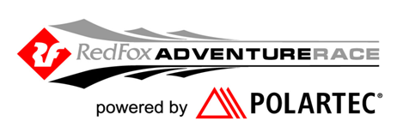
Red Fox Adventure Race XVIII powered by Polartec®
June 8-12, 2019

I am aware that participation in the 2019 Red Fox Adventure Race, including extreme activities and traveling at night with poor visibility, is potentially dangerous. Nevertheless, I accept all risks of participation in the race.

Any injuries I receive during the race will be my personal responsibility, and I waive any rights to seek any compensation for injuries suffered at the race from the organizers and their representatives.

Surname, name _______________________________________________________________

Date of birth _________________________________________________________________

Date ________________________________________________________________________

Signature ____________________________________________________________________

